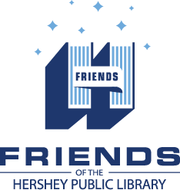

Strategic Plan 2016-17
Strategic Imperatives | Create Strategic Advantage | Strategic Goals | Strategic Results
Membership | Ensure financial viability and community involvement | •Revise membership levels  •Enhance membership value  •Marketing  •Book Sale
•Distribution | Manage costs and allocate funds in accordance with Friends’ Vision and Mission statements | •Expand programming  •Address budgeting process  •Reevaluate project  expenditures
Outreach | Explore innovative ways to reach new audiences | •Engage with community  partners  •Inclusive programming | •Cocoa Packs
Technology | Leverage use of technology to make tasks more efficient, flexible and in real time | •Program software  •Friends website  •Hardware upgrades  •Branding | • Transitioned from Volgistics to Wild Apricots.  •New Friends Logo
Organization | Deliver an effective organization strategy/structure to provide a relevant and stable volunteer base | •Board succession plan  •Recruitment  •Board Manual  •Committee structure

VISION

To ensure our community has a vibrant place to engage in lifelong curiosity,
creativity and learning.

MISSION

Through volunteers, outreach and funding, we partner with the Hershey Public Library and Derry Township to enrich our community and foster discovery.

